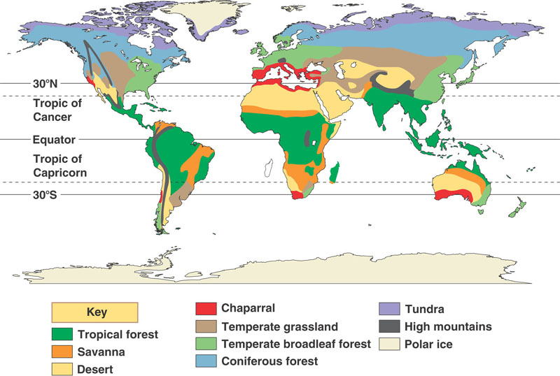

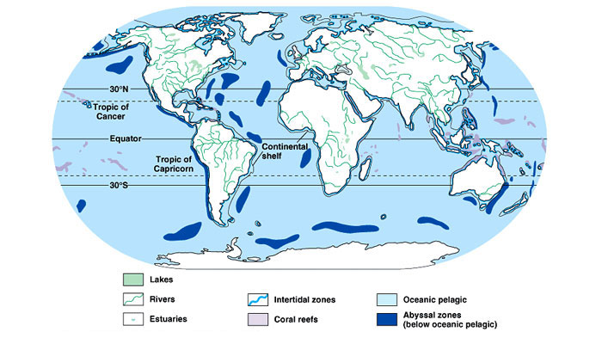

AQUATIC BIOMES  - Freshwater  - Freshwater wetlands  - Marine  - Intertidal zones  - Coral reef  - Estuaries | TERRESTRIAL BIOMES:  - Tundra  - Rainforest  - Savanna  - Taiga  - Temperate deciduous forest  - Coniferous Forest  - Temperate grassland  - Alpine  - Chaparral  - Desert

